
Sign Sync - LDAP
USER GUIDE
Nathan Nguyn
V1.0
Table of Contents
Overview 2
Disclaimer 2
Features 2
Prerequisites 2
Build Instructions 3
Configuration 4
How To – Group Mapping 4
AdobeSign Organizational Unit 4
Creating Groups 5
Adding / Removing Users to Groups 6
How To – Privileges 7
Create Privileges Mapping Groups 7
Add / Removing User Privileges 8
How To – Create Adobe Sign Integration Key 9
How To – Run Application 12
In-App Scheduler 12
Use Your Own Scheduler 12

Overview

Sign Sync allows for an automated process of moving users over from your Lightweight Directory Access Protocol (LDAP) into Adobe Sign.

Disclaimer
Sign Sync works as a one-way sync into Adobe Sign. All changes should be made either through LDAP. LDAP will be the true source of management. All changes made in Adobe Sign Interface should be configured the same in LDAP. Failure to do so will result in the changes reverting to the current mapping set in LDAP.

Features

The following is a list of automated features currently possible with Sign Sync.

Features | Description
Group Creation | New groups will be created during the synchronization.
User Privileges | Set individuals permission and have it synced over to Adobe Sign
User Group Synchronization | Users will be synchronized to their appropriate group mapping from either Admin Console or LDAP.
Activate/Deactivate Users | New Sign entitlement users will be activated into Adobe Sign Interface. Users that no longer have Sign entitlement will be deactivated.

Prerequisites

This is a list of all prerequisites that you should check off to verify that you have what is needed to start the deployment process. Please make sure you have all the prerequisites set up before using Sign Sync.

Python 3.6 | Python version 3.6 is recommended.
Pip | Python packaging management system.
Virtualenv | A tool to create isolated python environments
Adobe Sign Integration Key | The integration key to your Adobe Sign Console. Click Me
Text editor | This will be required to edit any configuration files.

Build Instructions

Platform-Independent Build Overview
- Create a directory called ss_standalone and place source inside that folder:
mkdir ss_standalone
- Change directory into ss_standalone:
cd ss_standalone
- Make a clean virtualenv for a 64-bit Python version 3.6 and activate it:
virtualenv -p python3 venv
- Navigate into the virtual env folder:
cd venv
- Activate the virtual environment:
source bin/activate
- Navigate back to your main directory:
cd ..
- Turn the application into an executable file:
make pex
- Open up the dist folder and copy the sign_sync_standalone file.
- Navigate back to the ss_standalone directory and change directory to sign_sync.
- Paste the sign_sync_standalone file into this directory. You are now able to target the application by using command ./sign_sync_standalone without having to activate the virtual environment.

Ubuntu
- An easy way to download python for Ubuntu 19.04 is with the following:
sudo apt-get update
- A standard C development environment for native extensions:
sudo apt-get install -y build-essential
- Use the following commands to download system packages:
sudo apt-get install -y python-dev python-pip python-virtualenv
sudo apt-get install -y python3-dev python3-venv
sudo apt-get install -y pkg-config libssl-dev libldap2-dev libsasl2-dev python-dbus libffi-dev
- Once you have your dependencies set up, follow the platform-independent build.

Mac OS:
- If you already have python3, pip, and virtualenv installed, go ahead and follow the platform-independent build.

Windows
- Make sure you have the latest Visual C++ Redistributable Libraries, which can be found here.
- You will need GNU-Win to use make, which can be downloaded here.
  - Once downloaded, please set the bin address into your system path.
  - http://gnuwin32.sourceforge.net/packages/make.html
  - https://www.youtube.com/watch?v=LO1LnhWWIow&t=963s
- Once you have GNU-Win installed, follow the Platform-Independent Build overview to install the application.

Configuration

There are two configuration files associated with Sign Sync. You can locate the configuration and the details within the yml files located in ss_standalone/sign_sync/config_templates. All configuration details are located in the configuration file. Please copy and paste them into ss_standalone/sign_sync/config before making changes.

- Connector-sign-sync.yml (Configuration to Adobe Sign)
- Connector-ldap.yml

How To – Group Mapping

The following section explains three important steps. First, we will create the main organizational unit where all our groups will be placed in. Next, we will then show you have to create groups. Finally, we will show you have to add and remove users from the groups.

AdobeSign Organizational Unit

The organizational unit will be the location of all your group mappings. Within this OU, you will create distribution groups, which will be mapped over to Adobe Sign Interface.
- Log into your server where your active directory is hosted on and open up Active Directory Users & Computers. You should see the following screen:

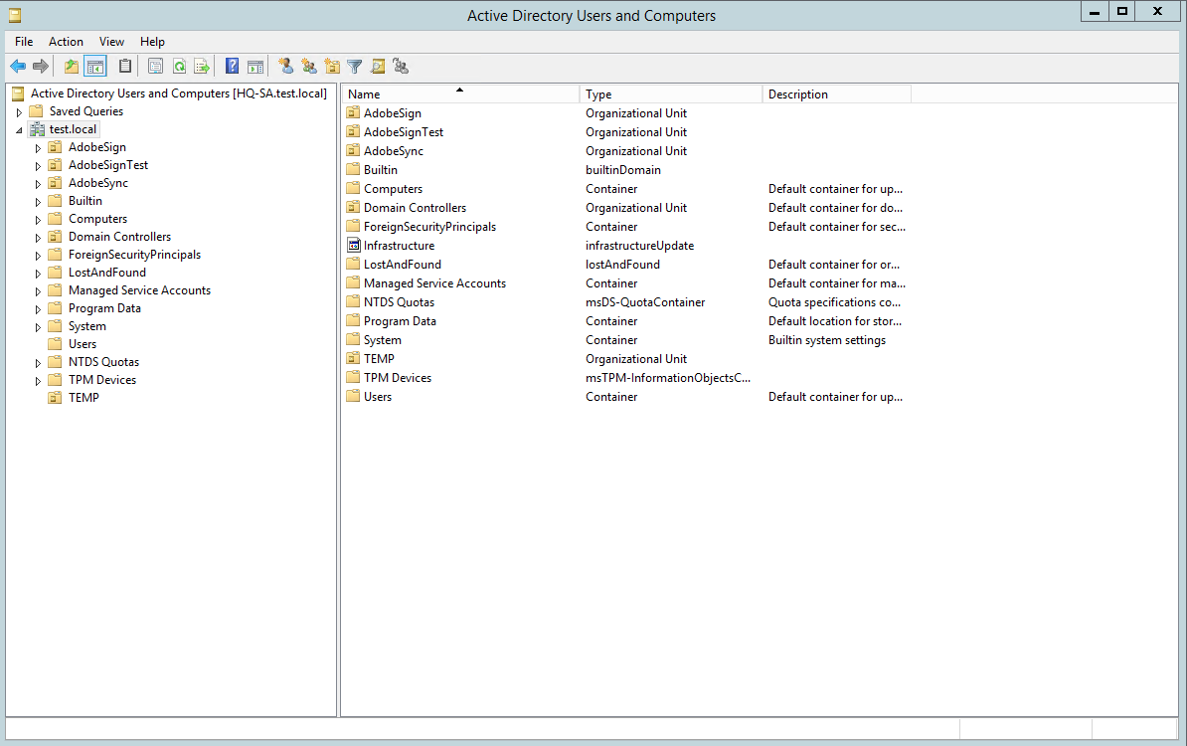
- Right click your domain (test.local) and hover over New and click Organizational Unit. You should see the following page:
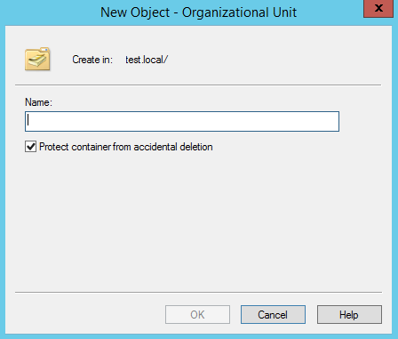

- Name the Organizational Unit AdobeSign and press OK. You have successfully set up the main mapping from LDAP to Adobe Sign.

Creating Groups

Any distribution groups created in this OU will be mapped over to Adobe Sign Interface. If you have existing groups in Adobe Sign, you will need to create a new distribution group with the same naming format. The different naming format will result in a new group being created in Adobe Sign.
- Right-click AdobeSign and hover over New and then select Group.

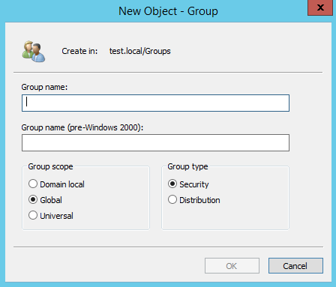

- Give the group a name and press OK. You can leave the group scope at Global and Group type to either Security or Distribution.

Adding / Removing Users to Groups

Once you’ve successfully created your groups, you will then need to add users to the following groups. Users within groups will be mapped over to their corresponding group in Adobe Sign.

- Double click the group that you would like to add users to.
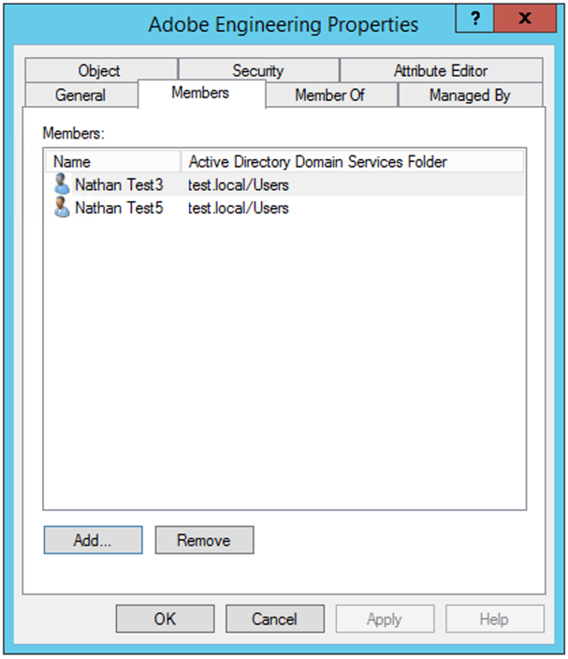
- To add a user simply click Add.

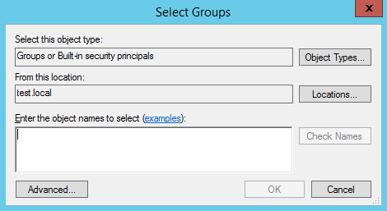

  - Enter the user’s identity by name or email address. You can click Check Names to verify if the user exists. You can add multiple users by separating user name or email with a “;”. Click Ok when you’re finished.
- To remove a user, simply highlight the user’s name and click remove.

How To – Privileges
In this section, we will show you how to set up privilege mapping. There are three main privileges in Adobe Sign.

- Account Admin – Can make changes on an account level
- Group Admin – Can only make changes on a group level
- Normal User – No privileges, just a normal Adobe Sign user.
Create Privileges Mapping Groups

- Right-click AdobeSign and hover over New and then select Group.

- Create a group named SIGN_ACCOUNT_ADMIN and press OK. Repeat and create another group named SIGN_GROUP_ADMIN.

Add / Removing User Privileges

Once you’ve successfully created your admin groups, simply add users to the group to give them privileges. SIGN_ACCOUNT_ADMIN will receive account admin rights in Adobe Sign. Users with SIGN_GROUP_ADMIN will have group admin rights. Users that are not in either group will have normal user privileges.

- Double click the group you are trying to modify users

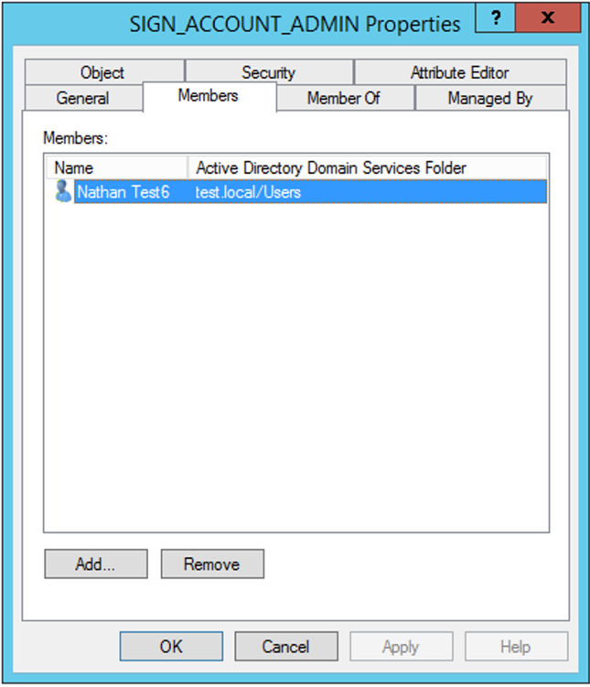

- To add a user simply click Add.

  - Enter in the user identity by name or email address. You can click Check Names to verify if the user exists. You can add multiple users by separating user name or email with a “;”. Click Ok when you’re finished.
- To remove a user, simply highlight the user name and click remove.

How To – Create Adobe Sign Integration Key

This section will show you how to create an Adobe Sign Integration Key.

- Log into your Adobe Sign Console.
- Click Account
- Locate Adobe Sign API tab
- Click API Information
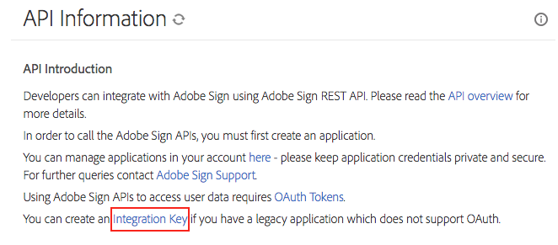
Figure 4: Sign Integration Key Location
- Click the integration key link.
  - If you do not see the integration link, please contact Support for assistance

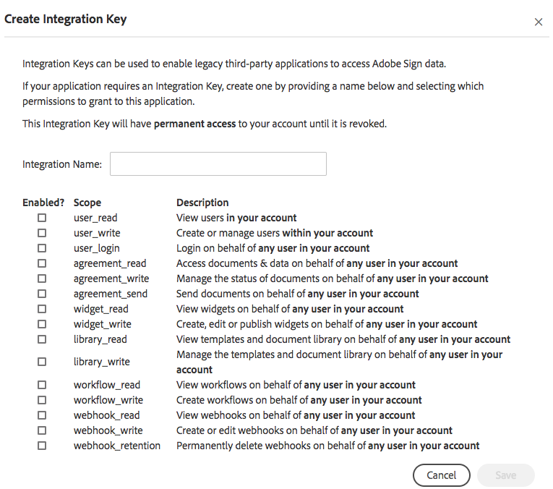
- Enter a name associated with this integration
- Select scopes associated with this integration. For more information, please click here.
- Click save
- Go to the personal preferences tab and select access token
- Find your integration and click it
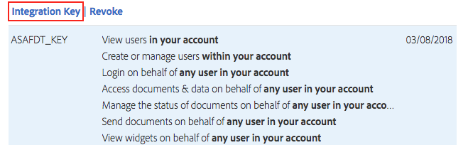

- Click the integration key link and your integration key should display like the image below:
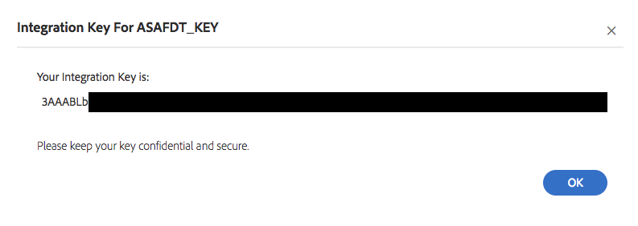

How To – Run Application

You have the ability to use either your own scheduler or the one provided for you in the application. The one provided is a simple interval scheduler that will just keep running until you exit out of the process.

In-App Scheduler

To use the in-app scheduler you need to first activate your virtual environment and install APScheduler dependency and run the script with an active virtual environment. Before you run the scheduler, please make sure you open up the file scheduler.py located in ss_standalone/sign_sync and set your intervals for hours, minutes, and seconds. One that’s completed, please follow the steps below.

- Change to your virtual environment folder
cd ss_standalone/venv
- Activate your virtual environment
source bin/activate
- Install Advanced Python Scheduler package
pip install apscheduler
- Change into the sign_sync directory where the scheduler file is located
cd ../sign_sync
- Run the scheduler
python scheduler.py

Use Your Personal Scheduler

To use your scheduler, simply target the executable file (sign_sycn_standalone) located in the ss_standalone/sign_sync directory. You can manually trigger it by using a ./sign_sync_standalone command within your scheduler.

